# **Planning and Progress Report**

**Group:** C1.027  
**Repository:** [AirNav-Logistics](https://github.com/DP2-C1-027/AirNav-Logistics)**Date:** February 15, 2025

### **Group Members:**

1. **Niza Cobo, Manuel Jesús**
   * Role: Manager, Developer
   * Email: mannizcob@alum.us.es
2. **Gomez Claraco, Nicolas**
   * Role: Developer
   * Email: nicgomcla@alum.us.es
3. **Campos Diez, Lucia**
   * Role: Tester, Developer
   * Email: luccamdie@alum.us.es

## **Table of Contents**

1. **Executive Summary**
2. **Revision Table**
3. **Introduction**
4. **Planning Chapter**
   * Tasks Performed
   * Estimated Budget
5. **Progress Chapter**
   * Progress Records
   * Conflicts and Resolution
   * Cost Comparison
6. **Conclusions**
7. **Bibliography**

## 

## 

## 

## 

## 

## 

## 

## 

## 

## 

## 

## 

## **Executive Summary**

This report is intended to provide an overview of the analysis, planning, and advancement of the AirNav-Logistics project, which is being developed to establish a complete logistics management system for charter flights at airports. The document outlines the tasks completed, the status of various features, and both the projected and actual budget. Additionally, it discusses the development methodology, challenges faced during the process, and compares the estimated versus actual costs. The aim is to confirm that the project is progressing as planned, within the set timeline and budget.

## **Revision Table**

|  |  |  |
| --- | --- | --- |
| **Revision** | **Date** | **Description** |
| 1 | 02/07/2025 | Creation of the analysis, planning, and progress report. |

## **Introduction**

This report provides an overview of the analysis, planning, and progress made in the AirNav-Logistics project, developed by group C1.027. The objective of the project is to create a system that supports airports in managing resources for charter flights. The report is organized into two sections: planning and progress, which offer a detailed description of the tasks assigned, their execution, related costs, and the conflicts managed.

The report structure includes a breakdown of the tasks completed by each team member, an analysis of the costs involved, and a summary of the conflicts addressed throughout the development of the project.

## 

## 

## 

## 

## 

## 

## 

## 

## 

## 

## 

## 

## **Planning Chapter**

### **Tasks Performed:**

**→Individual requirements:**

**Task 1:** **Technician ValidIdentifier**

* **Description**: Validation and implementation of the technician's identifier field (codigo), ensuring it complies with both pattern-based and contextual constraints as specified in the requirements.
* **Assigned to:** Lucía Campos (developer)
* **Planned Time:** 1 hour
* **Actual Time:** 1 hour

**Task 2: Update UML**

* **Description**: Review and update of the UML class diagrams to reflect the new entities, attributes, and relationships introduced in the second deliverable.
* **Assigned to:** Lucía Campos (developer)
* **Planned Time**: 1 hour
* **Actual Time**: 1 hour

**Task 3: Update all the authorise for the features**

* **Description**: Revision and implementation of authorization logic for technician-related features, ensuring proper access control based on ownership and publication status.
* **Assigned to:** Lucía Campos (developer)
* **Planned Time**: 10 hour
* **Actual Time**: 15 hours

**Task 4: Update involvedIn features**

* **Description**: Implementation and adjustment of the features related to the intermediate entity InvolvedIn, including creation, update, and deletion logic in compliance with domain rules.
* **Assigned to:** Lucía Campos (developer)
* **Planned Time**: 2 hours
* **Actual Time**: 4 hours

**Task 5: Update Planning and Progress Report**

* **Description**: Update of the planning and progress report to document the work done and time invested during the development of the second deliverable.**Assigned to:** Lucía Campos (developer)
* **Planned Time**: 2 hour
* **Actual Time**: 1 hour and 30 minutes

**Task 6: Update Analysis Report**

* **Description**: Inclusion of analysis related to the new functionality of the TechnicianDashboard, with a focus on structure, responsibilities, and interaction of system components.
* **Assigned to:** Lucía Campos (developer)
* **Planned Time**: 1 hour
* **Actual Time**: 1 hour

**Task 7: Update Testing Report**

* **Description**: Update of the testing report to include functional and performance tests for the newly implemented features in the second deliverable, including coverage analysis.
* **Assigned to:** Lucía Campos (developer)
* **Planned Time**: 3 hours
* **Actual Time**: 3 hours

**→Group requirements:**

**Task 8: Update Planning and Progress Report**

* **Description**: Collaborative update of the group’s planning and progress report, reflecting the evolution and organization of the deliverables.
* **Planned Time**: 1 hour
* **Actual Time**: 1 hour

**Task 9: Update Analysis Report**

* **Description**: Group-level review and refinement of the analysis report based on team discussions and feedback from the first deliverable.
* **Assigned to:** Lucía Campos (developer)
* **Planned Time**: 30 minutes
* **Actual Time**: 30 minutes

**Screenshots of Development Stages**

**1. Initial Task Definition in the "To Do" Lane**

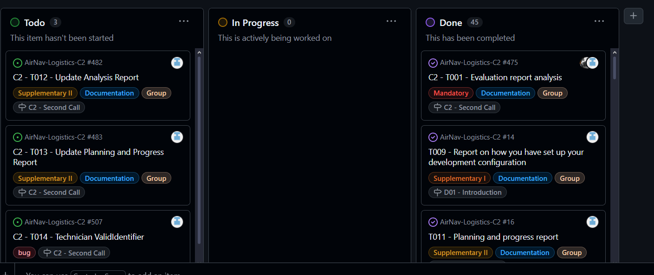

#### **2. Midway Through the Delivery: All Types of Tasks in Various Lanes**

#### **3. Final Task Completion in the "Done" Lane**

**Estimated Budget**

**Total Estimated Hours for Lucía Campos Díez:**  
**22 hours**

**Cost per role:**

**Developer (Lucía Campos Díez): €20/hour**  
**22 hours x €20 = €440**

**Amortization:**

* The amortization has been calculated using a linear method over three years, with an annual cost of €20.00 for the infrastructure used.

**Total Estimated Cost:**

* **Developer: €440**
* **Amortization: €20.00**
* **Total Estimated: €460**

**Progress Chapter**

#### **Progress Records**

|  |  |  |  |
| --- | --- | --- | --- |
| **Team Member** | **Performance Indicators** | **Value** | **Description** |
| Lucía Campos Díez | Task Completed | Good | All tasks completed on time and within the estimated time. |

### **Reward/Admonishment**

No formal reward was applied, but Lucía's efficient completion of tasks is noted as a positive contribution to the team's success.

### **Conflicts and Resolution**

No major conflicts arose during development. The team members worked collaboratively to address any technical challenges independently.

#### **Cost Comparison**

|  |  |  |
| --- | --- | --- |
| **Cost Component** | **Estimated Cost** | **Real Cost** |
| **Developer (Lucía Campos)** | **€440** | **€560** |
| **Amortization** | **€20.00** | **€20.00** |
| **Total Cost** | **€460** | **€580** |

### 

## 

## **Conclusions**

The AirNav-Logistics project is progressing smoothly, with all tasks completed within budget and timeframe. The modifications have improved UI coherence, and documentation is aligned with project expectations.

## 

## **Bibliography**

Intentionally blank.